3 Important Political Effects of National Popular Vote

Minority Voters
One in five Latino and Asian voters live in battleground states compared to one in three white voters. African-American voters are similarly concentrated in non-battleground states.

Turnout
There would be over 10 million additional votes in the presidential election if the voter turnout in battleground states (11% higher than spectator states) prevailed in all 50 states.

Counterbalance to Republican Voting Law Changes in 7 Largest Battleground States
We currently face a uniquely disadvantageous political situation where Republicans control both legislative houses and the governorship of the 7 largest battleground states (Florida–29, Pennsylvania–20, Ohio–18, Michigan–16, North Carolina–15, Virginia–13, and Wisconsin–10).
These states—which decide the Presidency—together possess 121 electoral votes—far greater than Clinton’s or Obama’s lead in the Electoral College.
Obama’s two-party percentages in these battleground states in 2012 were slender—Florida–50.4%, Pennsylvania–52.7%, Ohio–51.5%, Michigan–54.8%, North Carolina–49.0% (a loss), Virginia–52.0%, and Wisconsin–53.5%.
During 2013 and 2014, these seven Republican-controlled states will be passing legislation to require photo ID to vote (alone estimated to cost 1% of the vote), reduce early voting (and particularly Sunday voting popular in minority communities), ban election-day voter registration, require proof of citizenship to vote, purge voting rolls, restrict voter registration drives, limit absentee voting, and disenfranchise ex-felons (or slow re-enfranchisement). In addition, several of these states are also considering dividing their state’s electoral votes by congressional districts (which heavily favor Republicans in these 7 states).
The National Popular Vote bill is the only counter-balance on the horizon to Republican changes in the voting laws of the 7 largest battleground states.

Path to Changing the System by 2016
As of April 2013, the National Popular Vote bill has been enacted in states possessing 132 (49%) of the 270 electoral votes needed to activate the bill (Vermont, Maryland, Washington, Illinois, New Jersey, District of Columbia, Massachusetts, California, and Hawaii).
The bill passed the Oregon House on April 18, 2013 by a 38–21 vote.
Enactment by the eight remaining Democratic-controlled states would bring the number of electoral votes up to 206 (New York–29, Minnesota–10, Colorado–9, Oregon–7, Connecticut–7, West Virginia–5, Rhode Island–4, and Delaware–3).
Successful initiatives in November 2014 in 8 promising states (Michigan–16, Arizona–11, Maine–4, Missouri–10, Utah–6, Oklahoma–7, Nebraska–5, and Montana–3) would bring the number of electoral votes up to 272 electoral votes.
A strong showing of public support in November 2014 would provide the momentum for finishing the process of legislative enactment in 2015–2016 (e.g., in a “jilted” battleground state such as Pennsylvania or New Mexico or a state where political control changes in the 2014 elections).

Explanation of the National Popular Vote Bill
The National Popular Vote bill would guarantee the Presidency to the candidate who receives the most popular votes in all 50 states and the District of Columbia.
Under the National Popular Vote bill, all the electoral votes from the enacting states would be awarded to the presidential candidate who receives the most popular votes in all 50 states (and DC). The bill would take effect only when enacted by states possessing a majority of the electoral votes—that is, enough electoral votes to elect a President (270 of 538).
The shortcomings of the current system of electing the President stem from the winner-take-all rule (i.e., state statutes that award all of a state’s electoral votes to the candidate receiving the most popular votes in each separate state).
The most important consequence of the winner-take-all rule is that four out of five states were ignored in presidential elections. Candidates have no reason to pay any attention to the concerns of voters in states where they are comfortably ahead or hopelessly behind. As a result, only 12 states received any of the 253 post convention campaign events in 2012. Four states received two-thirds of these 253 events and a similar percentage of political spending (Ohio, Florida, Virginia, and Iowa).
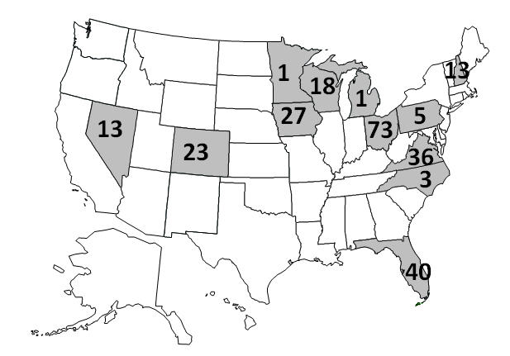
The winner-take-all rule has permitted candidates to win the Presidency without winning the most popular votes nationwide in four of our 57 presidential elections—1 in 14 times. A shift of 214,390 votes in 2012 would have elected Mitt Romney despite President Obama’s nationwide lead of almost 5,000,000 votes.
Article II, Section 1 of the U.S. Constitution gives the states exclusive control over awarding their electoral votes: “Each State shall appoint, in such Manner as the Legislature thereof may direct, a Number of Electors….” The winner-take-all rule is not in the Constitution. It was used by only three states in our nation’s first election in 1789.
The bill ensures that every vote, in every state, will matter in every presidential election.

